**Q1. A Short History of Java**

**Ans: Founded in 1991**

**Firstly by Sun Microsystems then it was taken over by Oracle in 2010**

**James Gosling, Patrick Naughton, Mike Sheridan were the main founders.**

**1st public implementation was Java 1.0 in 1996.**

**Q2 Reading Assignment: Java Language Features**

**Ans: Object Oriented**

**Simple**

**Secure**

**Robust**

**Platform Independent**

**Q3 Which Version of JDK Should I Use?**

**Ans: All the versions are suitable but 8,11,17 and 21 are LTS(Long-Term Support) versions**

**Q4 JDK Installation Directory Structure**

**Ans: JDK is firstly installed inside our system’s program files,**

**Inside this JDK, JRE is present**

**Assuming the JDK software is installed at /jdk-17,**

**Inside it bin, jre and lib are main subdirectories**

**bin**

**java* javac* javap* javah* javadoc\***

**lib**

**tools.jar dt.jar**

**jre**

**bin**

**java\***

**lib**

**applet**

**ext**

**jfxrt.jar localdata.jar**

**fonts**

**security**

**sparc**

**server**

**client**

**rt.jar**

**charsets.jar**

**This is the basic file structure inside the JDK**

**Q5 About Java Technology**

**Ans: Java technology is both a programming language and a platform.**

**Java language is a high-level language, and Java platform can be used on various OS**

**Q6 Coding Assignments**

1. **Hello World Program**:

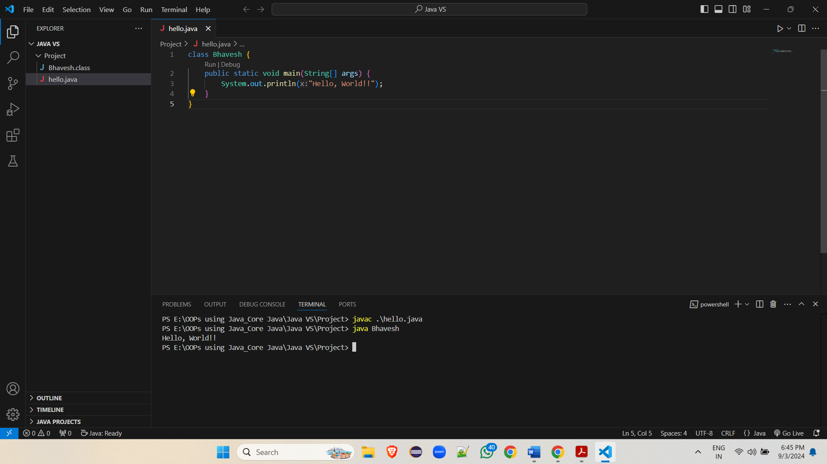

1. **Compile with Verbose Option:**

**It gives the detailed information about the compilation process.**

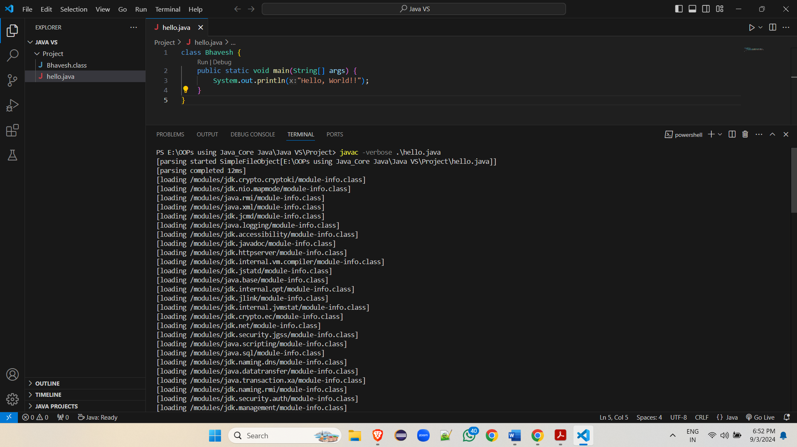

1. **Inspect Bytecode:**

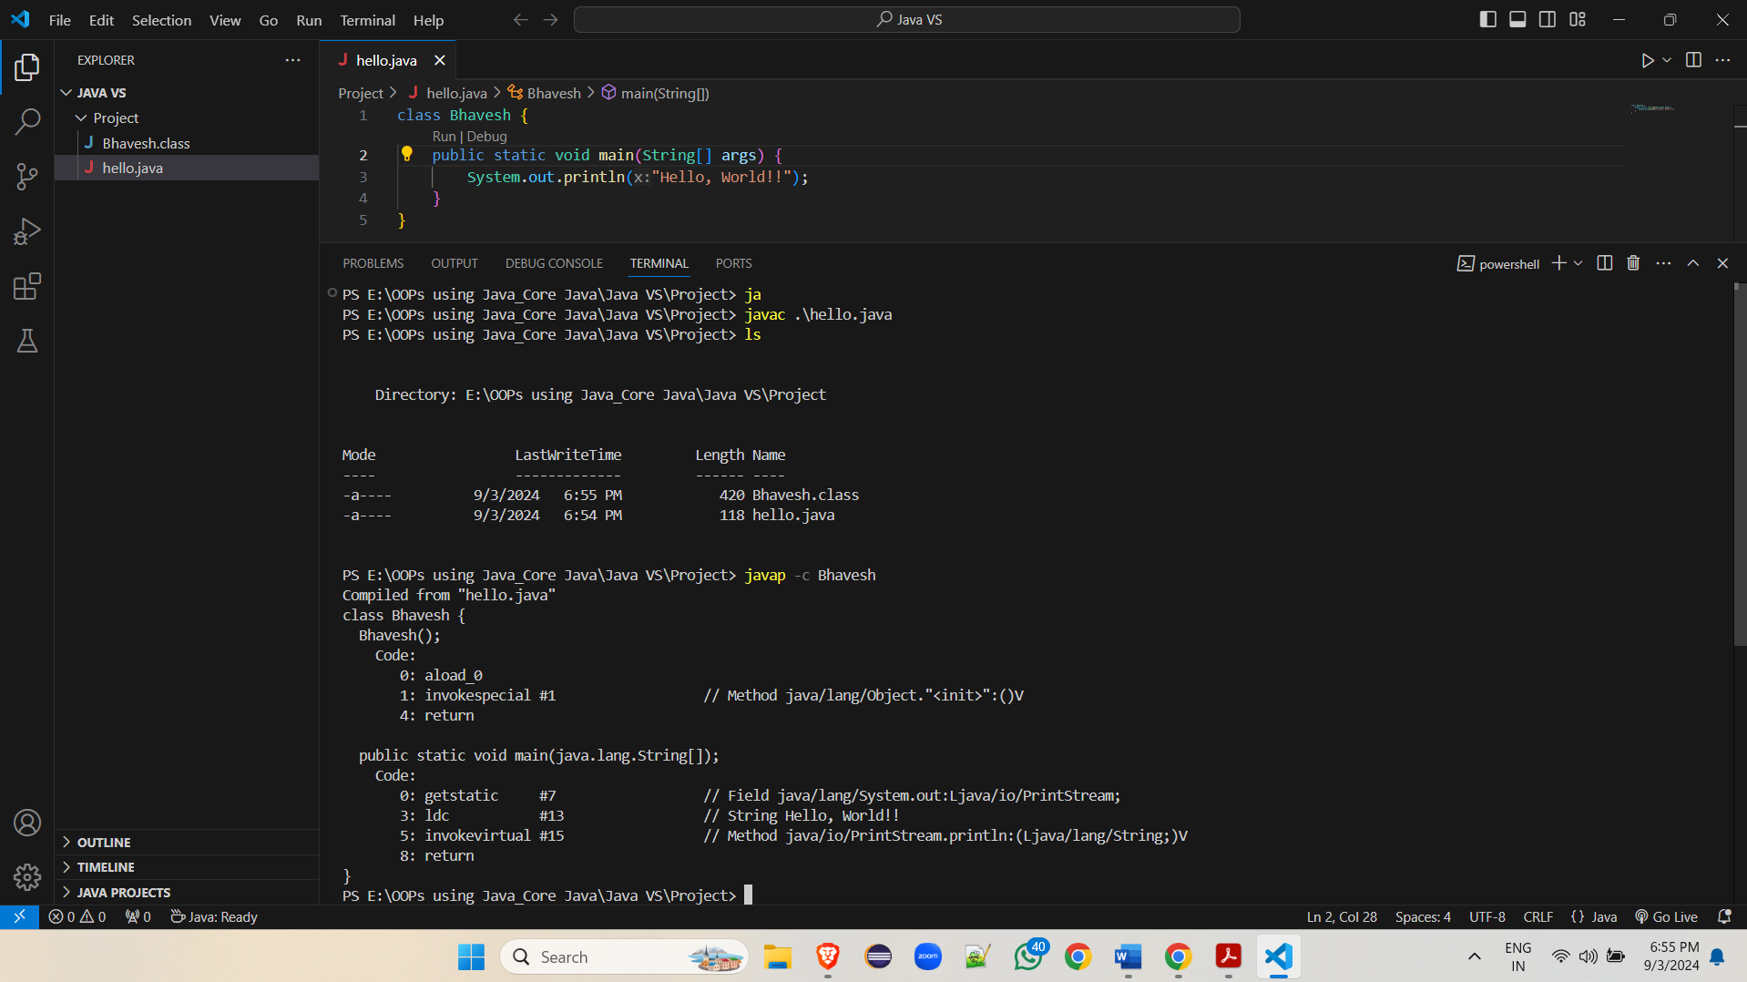

**Q7 The JVM Architecture Explained**

**Ans: The JVM is divided into three main subsystems:**

1. **ClassLoader Subsystem:**

**At runtime it loads, compiles and initializes the class file.**

1. **Runtime Data Area:**

**The Runtime Data Area is divided into five major components:**

* + 1. **Method area**
    2. **Heap Area**
    3. **Stack Area**
    4. **PC Registers**
    5. **Native Method stacks**

1. **Execution Engine:**

**The bytecode, which is assigned to the Runtime Data Area, will be executed by the Execution Engine.**